Randall Mitchell
English 322-899
Professor Rogers
March 14th, 2025

The Black Church in America

​The Black Church in America has historically been the foundation of Black People’s culture, serving not only as a place of worship, but also as a place for social, political, and cultural life. Just earlier this year, Black People, heavily influenced by the Black Church, boycotted Target stores for rolling back their DEI programs like it was 1965. I’m quite surprised I didn’t see Al Sharpton or Jesse Jackson outside yelling how much they care about “the culture.” Nonetheless, emerging during the era of slavery, the Black Church provided a platform for resistance against oppression. Over time, it has certainly played vital roles in American movements such as abolition, civil rights, police brutality, and other ongoing social justice initiatives.​
Social Media Presence and Strategies
In the digital age, many Black churches have embraced social media to extend their reach and engage with both their congregation and the broader community. Platforms like Facebook, Instagram, and YouTube are used to livestream services, share sermons, and promote community events. This online presence allows churches to maintain connections with members who may be unable to attend in person. As a matter of fact, 22% of the Black Church rather attend church online than in person ​(Singh).
Let’s take for instance our brother Mike Todd of Transformation church in Tulsa, Oklahoma. This pastor is on YouTube, Facebook, Instagram, TikTok, and every other social media one can find. And what do we find? We find pastor Todd showing off his Jordan sneaker collection, showboating his jewelry, and intertwining the world with those things of the Spirit. Is social media to blame? We see all smiles, glamor, and things that attract rich people, yet, didn’t Jesus tell the young rich man to leave all his possessions to the poor and following Him? Would Pastor Todd be willing to give up everything to truly follow Jesus? Or has social media impacted the Black Church to whereas it is almost unrecognizable?
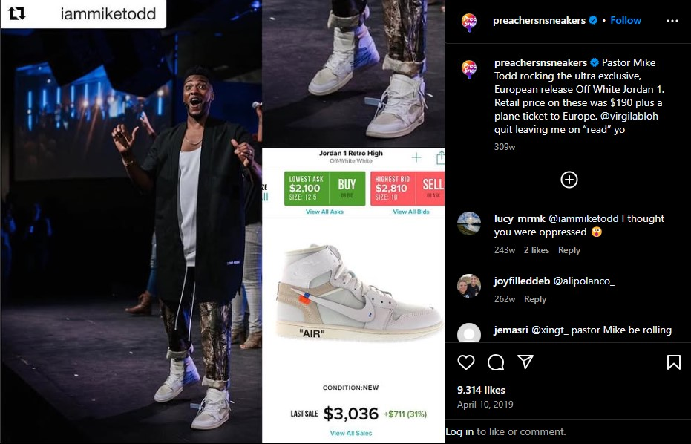
Effectiveness of Social Media Engagement
The effectiveness of these digital strategies varies. Churches that actively engage with their audience, provide relevant content that deals with what’s hot in the news, and encourage interactive participation tend to see higher levels of both online and physical engagement. However, challenges such as varying levels of digital literacy among the Black Church can impact the success of these plans. Research indicates that churches with clear social media strategies and dedicated personnel to manage online platforms are more successful in their reach, even if it means reaching new people in an unorthodox way.
A very effective way in engaging the community when it comes to the Black Church via online is starting mess with other religions, other pastors of the same faith and every other thing that is against their own biased interpretations of the Bible. Pastor Gino Jennings, a very outspoken pastor from Philadelphia, comes to mind. He’d say things like, “Mary is NOT the Mother of God. God has no Mother. God has no Father. God is Father,” and this would cause an uprising in the Catholic communities as he coined called Mary the Mother of God a hearsay (Horn). This has garnered Pastor Jennings a very large following, with him debating pastors from all over the world that his particular interpretation is correct. 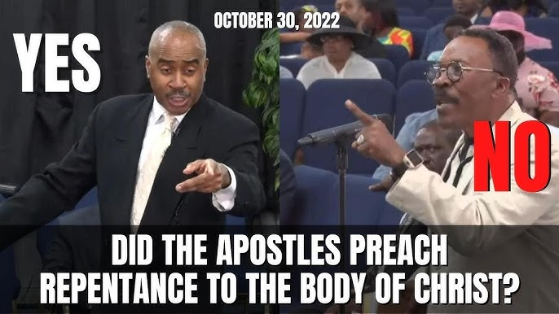
Narrative and Reinforcement
The Black Church has consistently reinforced a narrative of resilience, empowerment, and faith in the face of systemic adversity; yet, since we’ve found that empowerment, have we not swayed away from the truth? We can view sermons from the great Martin Luther King Jr., as he would preach on starting community programs, and make public statements that addressed issues such as racial injustice, economic disparities, and educational inequities. What happened? Dr. King preached about the unfairness in getting farm grants for African Americans in the 60’s, spoke up against real racism, and fought for everyone to be treated equally. Today, we got pastors telling us where to not shop at, or where to shop at if you’re wearing $3,000 sneakers on the pulpit.
Still, by aligning biblical teachings with the lived experiences of African Americans, the Black Church has provided a framework for understanding and even combating societal challenges. This narrative is often broadcasted through both traditional means being in the Church and by modern platforms, including social media, to reach a wider audience.​
Diminishing or Refuting Narratives
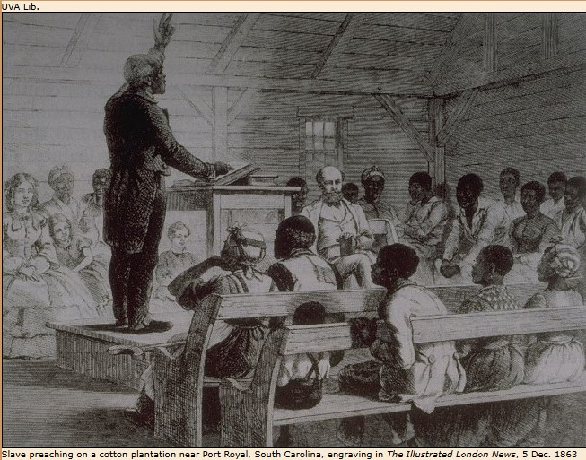
At times, the Black Church has also challenged narratives that are detrimental to the community. For example, it has been a vocal critic of ideologies that perpetuate racial discrimination and even in some cases, economic inequality. By organizing voter registration drives, hosting political forums, and participating in protests, the Black Church actively works to refute narratives that damage the dignity of Black People in America. However, there are internal critiques that suggest some churches may unconsciously perpetuate ideologies that are harmful, such as patriarchy, homophobia, and even the lack of self-worth. “The problem, of course, is that we couldn’t clean the theology. Most of our preachers and pastors had no more learning than the average congregant, so they spewed the same destructive rhetoric slave masters taught a century before. “We are nothing but filthy rags before a perfect savior,” I recall Pastor saying one morning. I frowned. I knew I had faults, but was I a filthy rag?” (Black). Women being unable to preach, slavery being atoned for, as long as Jesus was the master. When do we break those mental and spiritual chains?
Reaching Beyond the "Choir"
While the primary audience of the Black Church has traditionally been African Americans, many congregations have made concerted efforts to reach broader audiences. This includes engaging in interfaith dialogues, participating in multicultural associations, and also addressing universal social issues such as war, poverty, and education. By doing this, the Black Church extends its influence beyond its traditional base of churchgoers, advocating for justice and equity on a worldwide scale. However, some argue that the Black church's deep cultural ties can create perceptions of exclusivity, potentially hindering broader outreach efforts. For instance, Pastor Kelly out of Kansas City, Kansas runs a church called The Cure Church. It’s a mixed church, yet predominantly White Americans. Yet, when some “Brothas” come in for a sermon, all lights are on them. I went to The Cure Church a few times and it felt like I needed special attention, a special type of saving. Pastor would point me out, had all these other people ready to talk to him after church; but he refused them all to talk to me for many minutes, using Black slang to code switch of some sort. Am I not on the same playing field as everyone else? Would that special attention not drive someone away?
Opposition and Strategies
Opposition to the Black Church has historically come from entities that uphold systemic racism. During the civil rights era, white supremacist groups like the KKK targeted Black churches with violence to intimidate and suppress activism. In contemporary times, opposition can manifest through political efforts to marginalize the church's influence, such as policies that disproportionately affect African American communities or attempts to delegitimize social justice initiatives led by religious organizations. These strategies often involve propaganda, legislative actions, and economic pressures aimed at weakening the church's social and political impact when advocating for proponents. “A black minister at a ministerial breakfast to endorse a candidate for the U.S. Senate once observed that "America is a political animal, a political society, a political country, and those who have seen political power must understand that in order to have great power we must be part of the political process” (Jones).
Internal Critiques and Controversies
Despite its many contributions, the Black Church is not without internal critiques and controversies:​
- Integration of Secular Elements: The incorporation of secular music styles, such as rap and rock, into worship services has sparked debate. Critics argue that this dilutes the sacredness of worship, while proponents believe it makes the church more accessible to younger generations.​
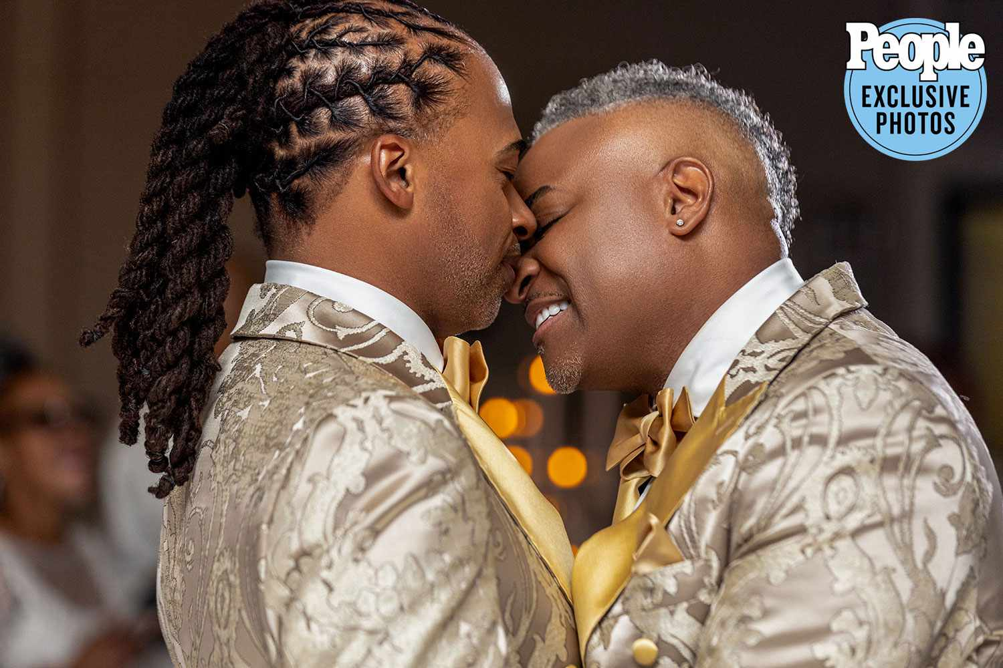
- Stance on LGBTQ+ Issues: The church's position on homosexuality has been a point of contention. While some denominations uphold traditional views on marriage and sexuality, others advocate for greater inclusivity. This divide has led to internal conflicts about the church's role in promoting social justice for all marginalized groups (Sands).
- Gender Roles and Leadership: The predominance of male leadership and traditional gender roles within the church has been criticized for perpetuating patriarchy and limiting women's participation in leadership positions. This has led to calls for reevaluating theological interpretations that restrict women's pastoral roles in the church. ​
- Financial Transparency and Accountability: Concerns about financial mismanagement and lack of transparency have arisen in some congregations, leading to distrust among members. Pastor Creflo Dollar asked his congregation to buy him a private jet. Nonetheless, ensuring ethical stewardship and open financial practices is crucial for maintaining trust within the community, be it the Church or the Strip club.
Conclusion
The Black Church in America remains a vital institution with a profound legacy of resilience, advocacy, and community building, even though it is becoming unrecognizable by each Sunday. While it faces challenges both internally and externally, its ability to adapt while also addressing contemporary issues will determine its continued relevance. Does the Black Church have to sacrifice its original teachings to remain relevant?

Works Cited

Black, Daniel. “What Prayer Won’t Fix: How the Black Church Perpetuates White Supremacy and Patriarchy.” Literary Hub, 1 Feb. 2023, www.lithub.com/what-prayer-wont-fix-how-the-black-church-perpetuates-white-supremacy-and-patriarchy/.
Horn, Trent. “Rebutting a Heretic on Mary, Mother of God.” Catholic Answers, 2024, www.catholic.com/audio/cot/841-rebutting-a-heretic-on-mary-mother-of-god-re-upload. Accessed 15 Mar. 2025.
Jones, Ken. “Analyzing the Social Political Activism of the Black Church in Light of the Two-KingdomsMotif|ModernReformation.” Www.modernreformation.org, www.modernreformation.org/resources/articles/analyzing-the-social-political-activism-of-the-black-church-in-light-of-the-two-kingdoms-motif.
Sands, Darren. “Black Denomination Upholds Stance against Same-Sex Marriage. A Gay Pastor in Its Ranks Seeks Change.” AP News, 12 Dec. 2024, www.apnews.com/article/black-church-ame-same-sex-marriage-lgbtq-1a9a4452fd860a8be10149db80d12853.
Singh, Chandraveer. “Social Media for Churches: 8 Best Strategies.” SocialPilot, 2 Aug. 2024, www.socialpilot.co/blog/social-media-for-churches.

